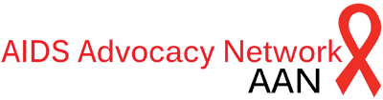

2017-2018
Welcome from the AIDS Advocacy Network Steering Committee Chairs!

Dear AMSA leader,
We are so excited that you and your chapter are interested in adding AIDS advocacy to your activities for this year. Our main campaign is making sure the federal appropriations include robust funding for global AIDS, including ensuring full funding for existing global AIDS programs, including the President’s Emergency Plan for AIDS Relief (PEPFAR) and the Global Fund to Fight AIDS, TB, and Malaria. World AIDS Day is on December 1st, 2017, and we hope the materials in this packet may help you prepare to act around this date but also throughout the academic calendar.
AIDS is a multi-faceted and complex disease, so our network does education and advocacy around multiple topics including AIDS prevention methods, TB, and trade agreements that interfere with access to medication. This packet should help you get up to speed with our campaigns and how your chapter can work with us to end AIDS. You’ll find background info about AAN, some of the strategies and tactics we use, and some ideas for how you could structure AAN meetings at your school. Everything listed is just a suggestion, and we’re happy to work with you to make a plan tailored to your chapter’s needs.
You may reach out to us via email at aan.chair@amsa.org.

Onwards,
Avanthi, Keanan, Shima, Daniel, Megan, Shivanthi

Avanthi Jayaweera, Virginia Commonwealth University School of Medicine
Keanan McGonigle, Tulane University School of Medicine
Shima Ge, Johns Hopkins University & George Washington Milken Institute School of Public Health
Megan Hunt, Clemson University
Shivanthi Gandhi, University of Mississippi
Daniel Gouger, MD, AMSA Education & Advocacy Fellow

Who are we?
AAN is made up of medical and premedical students dedicated to universal access to evidence-based prevention and treatment and to improving quality of life for people living with HIV. We are passionate about promoting global health equity, using evidence to guide policy, and ending AIDS without delay. We focus on putting political pressure on government officials at the federal level.

What are our core values?
We agree with Dr. Anthony Fauci, director of the National Institute for Allergy and Infectious Disease, when he reported that we can end the worst epidemic in history within the decade. We believe that health is a human right and that people everywhere deserve to live in a society with strong, evidence-based AIDS treatment and prevention programs.

How can your chapter be involved?
Ending AIDS will require a multi-pronged approach that includes creating the political will to fund the AIDS response and strengthen health systems globally to sustain the medical care required by people living with HIV/AIDS. To that end, we must educate and pressure lawmakers, focus on most-at-risk populations including injection drug users and men who have sex with men, and educate/mobilize ourselves and our peers at our universities to be an active part of the push to end AIDS.

How can we do this?
Our main goal is to end AIDS in this decade. Our strategy is to win federal budget support and policy changes that can bring the end of this pandemic. Our tactics include:
- Building relationships with legislators to teach about AIDS policy and give them concrete tasks to make universal access to treatment a reality,
- Bird-dogging (AKA approaching politicians in public and asking them to support the end of AIDS)
- Writing opinion-editorials in newspapers to educate the public and put pressure on politicians
- Organizing petitions or call-ins to politicians with the power to fund the end of AIDS
- Building a community of people calling for the end of AIDS with grassroots advocacy tactics

ISSUES:
Global AIDS Appropriations for PEPFAR
More than 1.5 million people die from AIDS yearly and over 36 million people are currently living with HIV around the world. Yet these deaths do not need to happen. Evidence has shown that treating HIV immediately upon diagnosis drastically reduces transmission. With treatment as prevention we can bring an end to the global AIDS epidemic by 2030. To reach this goal we must have proper funding towards programs like The President’s Emergency Plan for AIDS Relief (PEPFAR) which provides antiviral treatment for patients all around the world. Unfortunately PEPFAR funding has been cut or remained flat since 2011. If we step up now, key analysts estimate that we can prevent 10.8 million deaths from HIV/AIDS and 17.6 million infections by 2030 when compared to the status quo.
Currently PEPFAR funds HIV treatment in 50 countries but under its new strategy, they will only be focusing on 13 countries. This could lead to a resurgence of the HIV epidemic.
Resources:
http://www.healthgap.org/fundthefight
TAKE ACTION: Proceed to establish contact with your legislator via call-ins and in-person visits with staffers. Contact your member of Congress in the U.S. Senate and the U.S. House of Representatives to demand that Congress must increase funding to PEPFAR by $5 billion in FY 18 (increase of $700 million)
Introduction
Every year, millions of people around the world suffer from morbidity and premature mortality related to lack of access to life-saving medications. Medications treating conditions from HIV/AIDS to cancer to hypertension are readily available and were oftentimes developed using public funds, yet are frequently priced out of reach of those that need it the most. The oft-employed call-to-action “Pills cost pennies, greed costs lives,” continues to ring true, as pharmaceutical companies consistently report record profit margins while 1 million people died of HIV-related illnesses in 2016. High profile cases like Martin Shkreli’s abhorrent price increase of daraprim - a medication used to treat opportunistic infections associated with HIV - and Mylan’s increases on the EpiPen to treat anaphylaxis have brought the broken system into sharp relief. While these changes may have seemed criminal, these actors were acting well within their rights under the government sanctioned system of monopolizing health that puts us all at risk. There is perhaps no greater global health injustice than the current system of drug development and distribution.

“Where are the drugs? ….The drugs are where the disease is not. And where is the disease? The disease is where the drugs are not.”
- Dr. Peter Mugyenyi on global access to HIV/AIDS meds, July 2000

HIV/AIDS
Perhaps the most visible example of this injustice is the global HIV/AIDS epidemic. Around the world 36.9 million people are living with HIV (PLWH). Yet, just over 40% are on antiretroviral medications (15 millions people). With the increasing importance of treatment as prevention (TasP) as a model for achieving an AIDS-Free Generation - including a landmark CDC letter in Sept 2017 - access to these medications has never been more important. Nations like South Africa, where one in five adults are living with the virus, cannot be at the mercy of pharmaceutical companies’ charitable programs. Yet the current system of research and development (R&D) and intellectual property rights (IPR) left the nation without many options. Pioneering advocacy by the Treatment Action Group and others resulted in flexibilities in international law that put a nation’s public health ahead of Big Pharma’s profits. However, the fight persists, as low and middle income countries begin to face the challenges of chronic, lifestyle diseases.
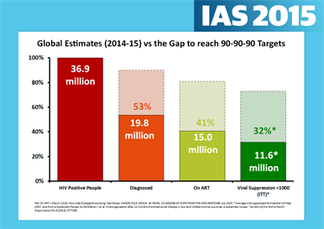

Figure 1. The global HIV/AIDS care cascade.
Just 15 million of nearly 20 million people living with known HIV infection were on antiretroviral medications in 2015. Just over 40% of all PLWH are on therapy.
Different countries, different needs
5.5 billion people or about 75% of the world’s population lives in low- and middle-income countries. As this population moves from the challenges of infectious diseases and general hygiene concerns into dealing with chronic, lifestyle diseases, access to medicines issues in these nations will change as well. Pharmaceutical companies perceive new markets in the chronic cardiovascular and respiratory conditions that these changes entail.
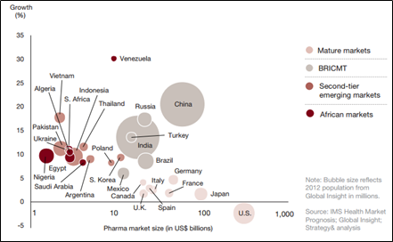

Figure 2. Growing targets for Big Pharma

In the US, recent developments in the the Hepatitis C Virus (HCV) epidemic has brought this dichotomy into sharp focus. New therapies to treat the virus, known as Direct-Acting Antivirals, average $84,000 for a 12-week course. Despite the devastating consequences of HCV infection - including liver cirrhosis requiring liver transplant or hepatocellular carcinoma, healthcare payers are severely restricting access to the medications. There were concerns that treating the full cohort of people living with HCV would ‘bankrupt’ state Medicaid programs.

What can I do?

Work on a campaign at your university!
Find your school on Universities Allied for Essential Medicines report card of universities. Figure out how your college is doing in terms of equitable access to discoveries funded using public funds or developed on public campuses. Explore what policies exist to ensure new inventions and discoveries are not priced out of reach of those that would most benefit from them!

Get plugged into a campaign!
Public Citizen’s Access to Medicines program is building a nation-wide campaign to fight for equitable access to publicly-funded discoveries for US citizens and more broadly. Get plugged into the campaign and get active at the local level!

Meet with your elected official
Make sure your elected officials know that you are an advocate for access to medicines at the national and international level! Whether that means fighting for bargaining power for Medicare or preventing stringent IP clauses in Free Trade Agreements, elected officials can fight for equitable access to drugs. Make sure they know there will be consequences for fighting for Big Pharma’s profits rather than a healthy future for all!

Zero tuberculosis deaths
Tuberculosis, a preventable and curable disease, takes the lives of 1.7 million people every year and remains the number one killer of people living with HIV. Yet with this outstanding prevalence of TB among this community, they are often not screened for the disease, partly due to poor testing methods. However in 2015, the World Health Organization developed a new screening test called the lipoarabinomannan (LAM) test that can detect TB earlier in patients with advanced HIV or CD4 counts <100. Prior standard testing involved checking the sputum for Mycobacterium tuberculosis bacteria but, for a population more susceptible to disseminated disease, this test is often not as effective. The LAM test costs about $3.50 in US currency and is noninvasive. The test includes a simple urine dipstick testing for the LAM protein which is an antigen found on TB bacteria. With better detection of TB, we can start patients on appropriate drug therapy to eliminate this curable disease.

TB targets the most susceptible and vulnerable populations such as those living in poverty, HIV+ individuals, the homeless, inmates, etc. With effective TB programs and medications, 95% of drug-sensitive TB can be cured. However, the rates of multi-drug-resistant (MDR) and extensively drug-resistant (XDR) TB are rising as a result of fragmented care that failed to follow evidence-based strategies to treat the initial infection and prevent transmission. AAN works alongside many organizations to advocate for policies that keep TB a priority in public health goals such as the Treatment Action Group (TAG), RESULTS, MSF, etc. TAG, a coalition of physicians, activists, and government officials, believe that it is possible to achieve zero tuberculosis deaths. Since TB is curable, this declaration is feasible if backed by political activism that will motivate governments to see this as a priority (see http://www.treatmentactiongroup.org/tb/advocacy/zero-declaration).

This pandemic will be uncontrollable if we don’t take action now to stop it in its track.
Resources:
http://www.treatmentactiongroup.org/tb/advocacy/zero-declaration
http://www.msfaccess.org/content/tuberculosis-%E2%80%93-curable-disease-continues-kill
http://www.treatmentactiongroup.org/tb

TAKE ACTION:
-Sign the zero declaration immediately and help circulate it (http://www.treatmentactiongroup.org/tb/advocacy/zero-declaration)
-Talk to your legislators about increasing PEPFAR funds and to support countries in implementing the LAM test
-Call on your National TB Program and National AIDS Program and ask that they update their national TB treatment guidelines to reflect WHO recommendations
-Host a session with your local chapter to discuss the new LAM test and schedule a meeting with your legislators

Pre-exposure prophylaxis (PrEP)
The HIV epidemic is still an important issue to discuss, especially in a time with healthcare constantly at risk. Great strides have been made regarding making HIV medications accessible to the general public through Medicaid and Medicare. Even so, there are numerous cases of individuals seroconverting to HIV positive despite available resources such as pre-exposure prophylaxis (PrEP). PrEP has been proven to lower the chances of contract HIV upwards of 90% though many people remain susceptible due to financial obstacles that place their HIV negative status at risk. With HIV treatment and prevention medications being covered uniformly by Medicaid and Medicare, there would be a significant decrease of the incidence of HIV.

Resources:
http://www.cdc.gov/hiv/basics/prep.html
http://www.whatisprep.org/
http://men.prepfacts.org/the-questions/
https://preplocator.org/

TAKE ACTION:
Contact your state/local legislatures and ask them to expand the coverage of HIV prevention and treatment medications, specifically for PrEP.

Syringe Services Program
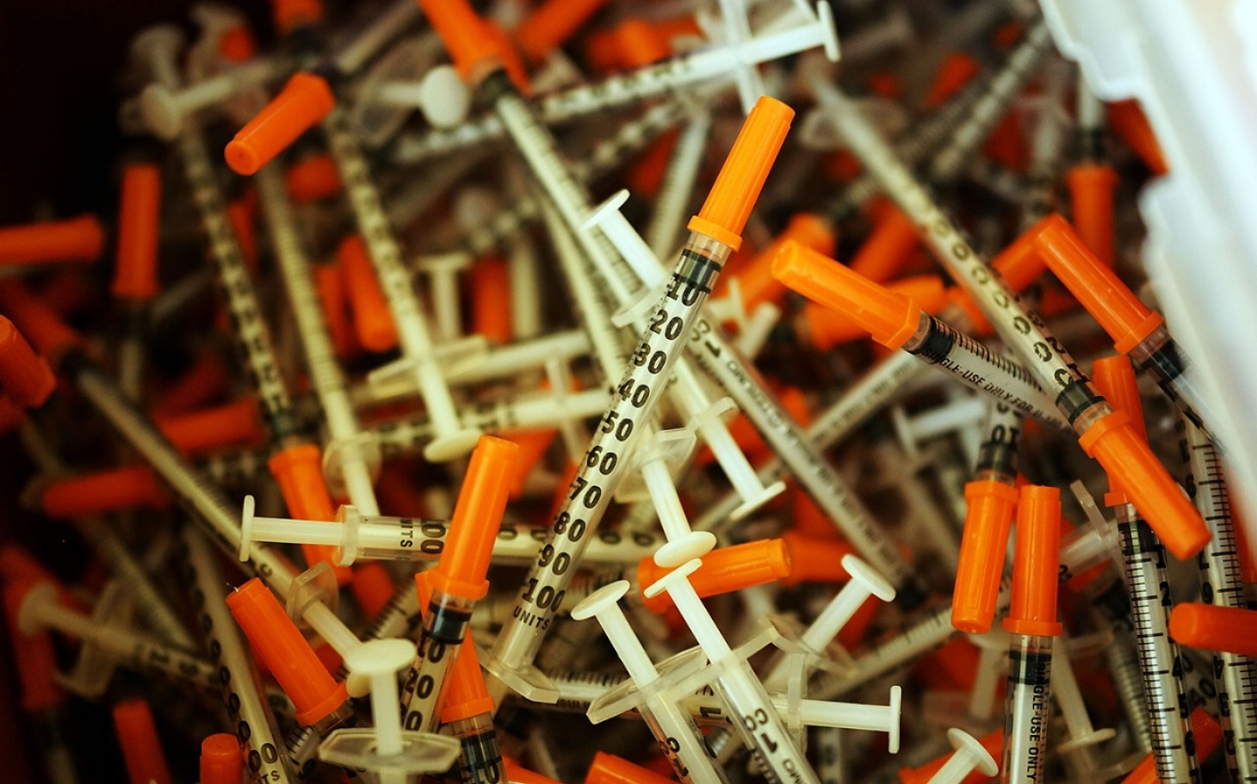 |  | 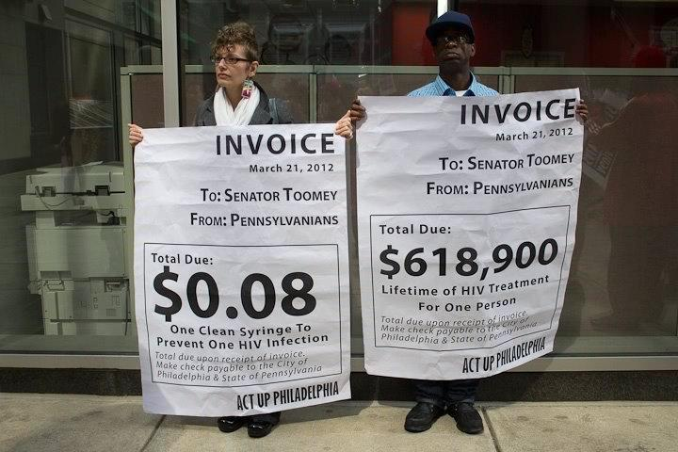
What is the Syringe Services Program (SSP), Syringe Exchange Program (SEP), Needle Exchange Program (NEP) and Needle-Syringe Exchange (NSP)?
- Programs that provide access to sterile, free syringes and safe disposal of used syringes.
Why do we need it?
- Promotes harm reduction, eg sites equipped to manage an overdose
  - shown to prevent HIV and Hep C transmission.
- Serves as an important link to critical medical services and programs: eg PrEP, PEP, Hep A & C vaccinations, STD/TB screening, etc.
Why do we need to fight for it?
- There’s more to be done. It must be recognized that IV drug use is widespread across all socioeconomic spectrums. See Austin, Indiana as an example that IV drug use in rural communities are present and increasing.
- Death from opioid overdose has steadily increased almost every year since 2001, surpassing gun homicide and traffic accidents in cause of death
- Only recently, in 2016, through committed actions from various organizations, community leaders, and SSP supporters, the federal ban on funding for domestic and international SSPs (reinstated in December 2011) was reversed.
TAKE ACTION:
How can I support SSPs?
- Awareness!
  - Host an informational session at your school!
  - Local syringe exchange site in your AMSA organization district? Check the directory!
    - Volunteer with the site.
    - Ask site staff if there’s anything you can help with. Talking with local city representatives to get funding support, providing medical staff, helping with advertising.
- Actions! Meeting with your senator or house representative.
Photo Courtesy of Harm Reduction: Activists arrested for syringe exchange support on the 2012 National Day of Action on Syringe Exchange, 2012. | 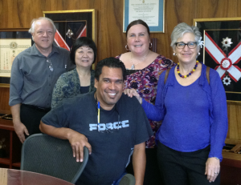  Photo Courtesy of Harm Reduction: Hawaiian activists meeting with Senator Inouye.
  - Making a call.
  - (need more information of current legislative actions: will contact Mary-Beth).
- Want to get really motivated?
  - Read about the medical students and residents that got together to set up Orange County’s FIRST SSP!
  - The point here is that you can advocate for your own local SSP too, the sky is the limit!
    - Request for a determination of need for a syringe program in your community via the CDC.
Resources:
- Powerpoints:
  - http://www.amfar.org/Articles/On-The-Hill/2013/Syringe-Services-Programs--Myth-vs--Fact/
- Media/Video:
  - https://youtu.be/Q0qcu3F7_BY?list=SPhdZ28BX5f63xWCWB7WNTTjyb0yktVHuT
  - https://www.youtube.com/watch?v=sCtj19TfgE8
  - https://www.youtube.com/watch?v=Fvd9RrB84QQ
- Naloxone training/free narcan training devices:
  - http://prescribetoprevent.org/patient-education/videos-for-download/
  - To receive a free trainer of the auto-injectable naloxone
    - http://www.evzio.com/hcp/global/sign-up.php
  - To apply to receive 200 free auto-injectors (with real naloxone):
    - https://external-kaleo.idea-point.com/Process.aspx?groupid=GRANTS
  - Free naloxone for every high school
    - http://www.huffingtonpost.com/entry/naloxone-overdose-reversal-high-schools_us_56a68951e4b0404eb8f29097

